COMPETITOR’S NAME
COMPETITOR’S MOBILE NUMBER
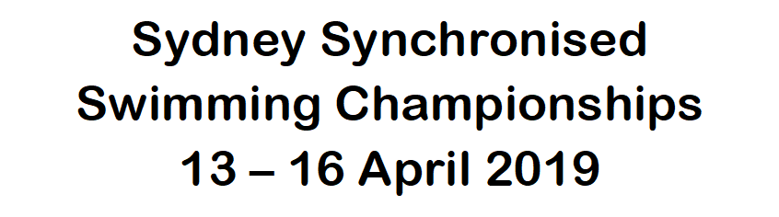
EMERGENCY CONTACT DETAILS
NAME OF EMERGENCY CONTACT | RELATIONSHIP TO COMPETITOR | PHONE NUMBER(S) | COMMENTS

MEDICAL INSURANCE DETAILS
MEDICARE NUMBER |  |  | REFERENCE |  | EXPIRY DATE
PRIVATE HEALTH FUND |  | MEMBERSHIP NUMBER
DOCTOR’S NAME |  | DOCTOR’S PHONE NO.

Please note any special dietary requirements for this Competitor:

Please note any allergies this Competitor has:
ALLERGIC TO | REACTION SYMPTOMS | TREATMENT | COMMENTS

Please note any medication this Competitor takes:
REASON FOR MEDICATION | MEDICATION TAKEN | DOSAGE AMOUNT AND FREQUENCY | SELF MEDICATE or ASSISTANCE REQUIRED | COMMENTS

 | YES | NO
Should feel unwell, are you happy for the Coach or House Mother to administer pain relief in the form of Paracetamol or Ibuprofen if appropriate?
Sydney Synchronised Swimming Championships 13 – 16 April 2019
Please note any other medical related information for this Competitor that the Coach and House Mothers need to be aware of (e.g. Contact Lenses, Dental Prosthesis, etc.):

PLEASE ADD ANY GENERAL COMMENTS OR NOTES APPLICABLE TO THE COMPETITOR FOR THEIR COACHES AND HOUSE MOTHER:

COMPETITOR SIGNATURE
PARENT OR GUARDIAN SIGNATURE (IF UNDER 18)
DATE

